Atomic Spectra

EQUIPMENT

 | INCLUDED:
1 | Spectrophotometer System | OS-8539
1 | Small Round Base (set of 2) | ME-8974A
2 | 25 cm Threaded Rod | ME-8988
1 | Low Pressure Sodium Light Source | OS-9287A
1 | Mercury Vapor Light Source | OS-9286
1 | Spectral Tube Power Supply and Mount | SE-9460
1 | Hydrogen Spectral Tube | SE-9461
1 | Helium Spectral Tube | SE-9462
NOT INCLUDED, BUT REQUIRED:
1 | ScienceWorkshop 750 Interface | CI-7650
1 | DataStudio | CI-6870

INTRODUCTION

The atomic spectra of Hydrogen, Helium, and Mercury are scanned by hand using a grating spectrophotometer that measures relative light intensity as a function of angle. From the resulting graph, the wavelengths of the spectral lines are determined by measuring the angle from the central maximum to each line. First and second order lines are examined. The spectrum of Sodium (the Sodium doublet cannot be resolved) is used to calibrate the diffraction grating.

The wavelengths of the spectral lines are compared to the accepted values and, in the case of Hydrogen, the electron orbit transitions corresponding to the lines are identified.

THEORY

To find the wavelength of the spectral lines:
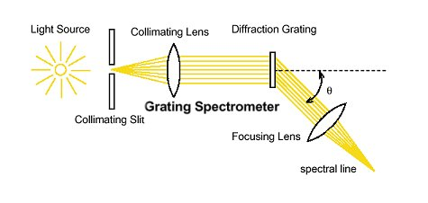
As light passes through a diffraction grating, the light bends to form a diffraction pattern. The angles to the maxima in the diffraction pattern are given by

(m = 0, 1, 2, ...) (1)

where d is the separation between the lines on the grating, λ is the wavelength of the light, and m is the order number.

Light is given off by an atom when an excited electron decays from a higher energy orbit to a lower energy orbit. The energy levels of the electron in a hydrogen atom are given by

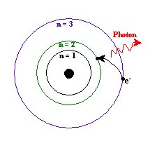

(2)

where m_{e} is the mass of the electron, e is the charge of the electron, ε_{o} is the permittivity constant, h is Planck's constant, and n is the energy level number (1,2,3,...). Plugging these numbers into Equation (2) gives

. (3)

The energy of the photon, ΔE, is the negative of the loss of energy of the electron and is given by

. (4)

For the visible photons given off by Hydrogen, the final energy level is n_{f} = 2. The wavelength, λ, of the photon given off is determined using

(5)

where c is the speed of light and f is the frequency: . (6)

SET UP

1. Plug in the Sodium and Mercury lamps and turn them on so they can warm up before you use them. WARNING: Do not look directly into the Mercury lamp.

2. If the spectrophotometer needs to be assembled, go to the assembly instructions by opening the file called "Spectrophotometer Assembly". NOTE: The diffraction grating is on the side of the grating mount that is toward the collimating lens and the light source. The grating side of the plate glass must be on the 0-180 degree line on the degree table.

3. Put the spectrophotometer on two rod stands so you can adjust the height to match the height of the various light sources.
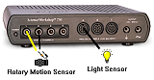

4. Plug the Rotary Motion Sensor and the High Sensitivity Light Sensor into the ScienceWorkshop 750 interface.

5. Attach a grounding wire from the spectrophotometer to ground. Your teacher will explain how to attach to ground. Do not plug wires into wall sockets!

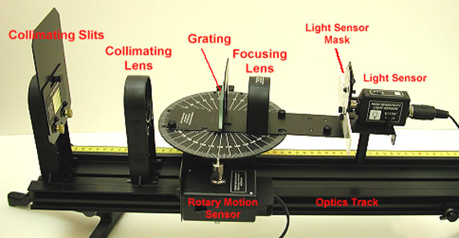
Figure 1: Setup

6. Start the DataStudio program and open the file called "Atomic Spectra".

PROCEDURE

Determining the Grating Line Separation

Use the Sodium (Na) lamp to determine the separation, d, of the lines on the grating. The yellow lines of Sodium have known wavelengths: 589.0 nm and 589.6 nm. These lines are so close in wavelength that they will look like one line through the spectroscope. Assume this line as the average wavelength of 589.3 nm.

Sodium Suggested Settings
Light Sensor Gain Switch | x10
Light Sensor Properties Sensitivity | Low
Collimating Slit | #1
Light Sensor Slit | #2

1. Suggestions for the settings are given at right. While scanning, turn off the room lights and turn the computer screen away from the light sensor.

2. Adjust the height of the spectrophotometer to match the center of the Sodium source.
Start the scan on one side of the central maximum and scan very slowly across the central maximum and the first side maximum. See Figures 2 and 3.
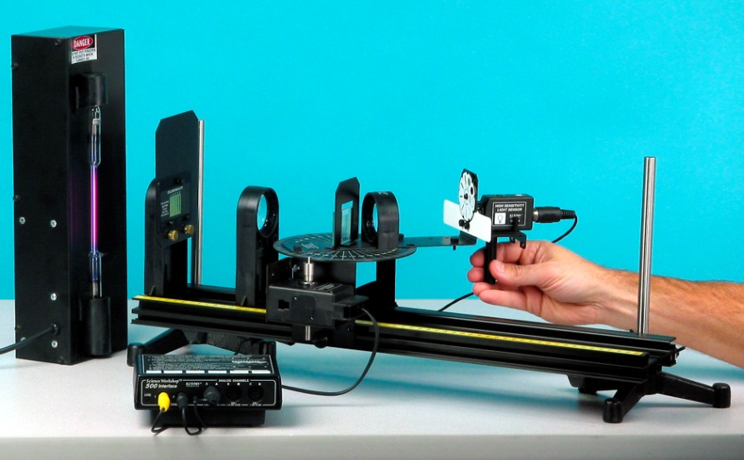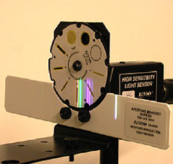
Figure 2: Close-up of Light Sensor Figure 3: Scanning the Spectrum

3. Using the Smart Tool on the graph, measure the angle from the central maximum to the first side maximum (m =1).

4. Sketch the graph of the spectrum or, if a printer is available, print the graph.

5. Using the average wavelength of the Sodium line, 589.3 nm, calculate the grating line separation: This is the value of d that you will use for the rest of this experiment.

Helium Spectrum

1. Replace the Sodium lamp with the Helium tube. Adjust the height of the spectrophotometer to match the center of the Helium tube.

Helium Suggested Settings
Light Sensor Gain Switch | x100
Light Sensor Properties Sensitivity | Low
Collimating Slit | #4
Light Sensor Slit | #4

2. Change the settings to those suggested at right.

3. Start the scan on one side of the central maximum and scan very slowly across the central maximum and all the different colors of the first side maxima (m=1).

4. Using the Note (A) button at the top of the graph, label the peaks by the color of the corresponding spectral line.

5. Using the Smart Tool on the graph, measure the angle from the central maximum to the first side maximum (m =1) for at least two different colors.

6. Sketch the graph of the spectrum or, if a printer is available, print the graph.

7. Use these angles to determine the wavelengths of these colors. Use the grating line separation that you determined with the Sodium spectrum.

8. Look up the accepted values for the wavelengths of these lines and find the percent differences from your values.

Hydrogen Spectrum

1. Notice that the new settings require that you change the sensitivity of the Light Sensor in the Setup window. To do this, click on Setup at the top of this page and double-click on the Light Sensor icon. Then go to the calibration and select High for the Sensitivity.

Hydrogen Suggested Settings
Light Sensor Gain Switch | x100
Light Sensor Properties Sensitivity | High
Collimating Slit | #3
Light Sensor Slit | #2

2. Replace the Helium tube with the Hydrogen tube. CAUTION: These tubes can be very hot! Adjust the height of the spectrophotometer to match the center of the Hydrogen tube. Start the scan on one side of the central maximum and scan very slowly across the central maximum and all the different colors of the first side maxima (m=1).

3. Using the Note (A) button at the top of the graph, label the peaks by the color of the corresponding spectral line.

4. Using the Smart Tool on the graph, measure the angle from the central maximum to the first side maximum (m =1) for three different colors.

5. Sketch the graph of the spectrum or, if a printer is available, print the graph.

6. Use these angles to determine the wavelengths of these colors. Use the grating line separation that you determined with the Sodium spectrum.

7. Look up the accepted values for the wavelengths of these lines and find the percent differences from your values.

8. For each of the wavelengths you found for the hydrogen lines, calculate the energy of the photon in eV.

9. Now, using these energies, calculate the number of the initial energy level from which the electron decayed from when it emitted each of the photons.

Mercury Spectrum

WARNING: Do not look directly into the Mercury lamp.

1. Notice that the settings require that you change the sensitivity of the Light Sensor in the Setup window. To do this, click on Setup at the top of this page and double-click on the Light Sensor icon. Then go to the calibration and select Low for the Sensitivity.

Mercury Suggested Settings
Light Sensor Gain Switch | x1
Light Sensor Properties Sensitivity | Low
Collimating Slit | #1
Light Sensor Slit | #1

2. Replace the Hydrogen tube power supply with the Mercury source. Adjust the height of the spectrophotometer to match the center of the Mercury source.

3. Start the scan on one side of the central maximum and scan very slowly across the central maximum and all the different colors of the first side maxima (m=1).

4. Using the Note (A) button at the top of the graph, label the peaks by the color of the corresponding spectral line.

5. Using the Smart Tool on the graph, measure the angle from the central maximum to the first side maximum (m =1) for three different colors.

6. Sketch the graph of the spectrum or, if a printer is available, print the graph.

7. Use these angles to determine the wavelengths of these colors. Use the grating line separation that you determined with the Sodium spectrum.

8. Look up the accepted values for the wavelengths of these lines and find the percent differences from your values.

Mercury Doublet

1. Switch the gain switch on the light sensor to x100. Start the scan on one side of the central maximum and scan across the central maximum and all the different colors of the first side maxima (m=1) and then continue to scan very slowly across the second order lines (m=2).

Mercury Doublet Suggested Settings
Light Sensor Gain Switch | x100
Light Sensor Properties Sensitivity | Low
Collimating Slit | #1
Light Sensor Slit | #1

2. Using the Smart Tool on the graph, measure the angle from the central maximum to the each of the two second order orange lines. Zoom in on the orange lines so you can resolve both of the lines. Record these angles and calculate the wavelengths of this doublet in the box.

3. Look up the accepted values for the wavelengths of the doublet and find the percent differences from your values.

